



Contents

.1 Executive Summary 3

.2 Business Model Canvas 3

.2.1 CUSTOMER SEGMENT 3

.2.2 CUSTOMER RELATIONSHIPS CHANNELS 3

.2.3 CHANNELS 4

.2.4 VALUE PROPOSITIONS 4

.2.5 KEY PARTNERS 4

.2.6 KEY ACTIVITIES 4

.2.7 KEY RESOURCES 4

.2.8 COST STRUCTURE 5

.2.9 REVENUE STREAMS 5

.3 Market Opportunity: 5

.4 Market Study 5

.4.1 PEST Analysis 5

.4.2 The 8 Ps 8

.4.3 SWOT Analysis 12

.5 Customer Analysis 13

.5.1 Customer Pain Points 13

.5.2 Customer Segmentation for Remotely 15

.5.3 PERSONA 16

17

.6 Competitors Analysis 18

.7 Objective: 21

.7.1 Business Objective: 21

.7.2 Marketing Objective: 21

.7.3 Digital Marketing Objective: 21

.8 Unique Value Proposition 21

.9 Unique Selling Point 22

.10 Tone of Voice 22

.11 Messaging and Storytelling 22

.12 Digital Marketing Channels 23

.12.1 LinkedIn: 23

.12.2 Instagram: 24

.12.3 Facebook: 24

.12.4 X (Twitter): 24

.12.5 Website: 24

.12.6 YouTube: 24

.13 Remotely Marketing plan 25

.13.1 Content Marketing: 25

.13.2 SEO & Website Optimization 25

.13.3 Paid Advertising 26

∙ Facebook Ads 26

.13.4 Email Marketing 31

.13.5 Influencer and Partnership Marketing 31

.13.6 Referral Program 33

.13.7 Webinars and Events 33

.13.8 Mobile Marketing Strategy 33

.13.9 Community Building: 35

.13.10 Search Engine Optimization (SEO) 35

.13.11 Content Calendar 36

.13.12 Budget 37

.13.13 Performance Tracking and KPIs 38

## Executive Summary

REMOTELY aims to revolutionize how businesses in Arabic countries access specialized expertise by offering a comprehensive platform for hiring virtual experts. This new venture provides businesses with the flexibility to hire professionals for short-term projects or limited-time engagements, catering to a wide range of business needs including accounting, human resources, public relations, digital marketing, graphic design, administration, logistics, and translation.

**Services:** The company will offer a diverse range of services, including:

* **Accounting and Finance:** Bookkeeping, financial analysis, and tax preparation.
* **Human Resources:** Recruitment, employee relations, and HR policy development.
* **Public Relations:** Media outreach, crisis communication, and brand management.
* **Digital Marketing:** SEO, social media management, content creation, and PPC advertising.
* **Graphic Design:** Branding, digital design, and multimedia production.
* **Administration:** Virtual assistants, project management, and data entry.
* **Translation:** Multilingual document translation and interpretation services.

## Business Model Canvas

### CUSTOMER SEGMENT

* **SMEs**: Small and medium enterprises in need of flexible, short-term virtual assistance.
* **Startups**: Growing businesses looking for expert support without full-time hiring commitments.
* **Corporates:** Larger organizations needing temporary, project-based virtual experts.
* **Entrepreneurs:** Business owners looking for administrative and operational support without the hassle of long-term contracts**.**

### CUSTOMER RELATIONSHIPS CHANNELS

* **Dedicated Account Management**: Each client has a personal account manager.
* **In-Person Support:** Clients can meet us at our onsite office for consultations. Tailored Solutions: Customized virtual assistant services designed to meet client needs.
* **Ongoing Support**: Regular check-ins to ensure client satisfaction and successful project execution.

### CHANNELS

* **Website**: Our primary hub for client onboarding and service management.
* **Social Media Platforms**: such as LinkedIn, Instagram, and Facebook for outreach and client engagement.
* **Freelancer Platforms**: Used to source talent as needed.
* **Onsite Office:** A physical space for client meetings and consultations, fostering stronger relationships.
* **Direct Sales**: Outreach to businesses via networking and personalized email campaigns.

### VALUE PROPOSITIONS

* Remotely provides a one-stop solution for businesses, with a dedicated account manager responsible for sourcing qualified talent whenever needed. This means no need to search across multiple freelance platforms, ensuring clients avoid the risk and hassle of hiring unqualified individuals.
* We deliver pre-vetted talent, making us the only destination for businesses looking for reliable, flexible virtual assistants, backed by an option for in-person meetings at our office.

### KEY PARTNERS

* **Freelancer Platforms**: Partner platforms for sourcing pre-vetted freelancers.
* **Technology Providers**: Tools for project management and virtual communication.
* **Training and Certification Partners**: For developing the skills of virtual assistants.
* **Local Business Networks**: Collaboration with regional business associations.

### KEY ACTIVITIES

* **Talent Acquisition & Vetting**: Recruiting and vetting skilled virtual experts.
* **Client Relationship Management**: Providing dedicated account managers to handle all client needs.
* **Onsite Client Engagement**: Offering in-person meetings at our offices to build trust and deepen relationships.
* **Service Delivery**: Ensuring smooth project execution and expert support.

### KEY RESOURCES

* **Skilled Virtual Experts**: A vetted network of professionals in various business domains.
* **Technology Platforms**: Digital tools to facilitate seamless communication and project tracking. Account Managers: Experts dedicated to ensuring smooth client engagement.
* **Physical Office**: An onsite office for client meetings and relationship building.
* **Brand Reputation**: A trusted name in the virtual assistance space

### COST STRUCTURE

* **Talent Acquisition Costs**: Recruiting, vetting, and onboarding virtual experts.
* **Technology Infrastructure**: Platforms and software for communication and project management.
* **Marketing and Sales**: Digital marketing, lead generation, and client acquisition.
* **Office Expenses**: Rent, utilities, and operational costs for the onsite office.
* **Account Managers Salaries**: Compensation for the dedicated client relationship managers.
* **Operational Costs**: General administrative expenses for smooth business functioning.

### REVENUE STREAMS

* **Subscription Fees**: Monthly packages for businesses requiring ongoing virtual assistance.
* **Project-Based Fees**: One-time payments for short-term or project-based services.
* **Talent Management Fees:** Additional fees for managing contracts, payments, and project oversight.
* **Consulting Fees**: For providing strategic advice beyond virtual assistance services Remotely.

## Market Opportunity:

In today’s dynamic business environment, companies increasingly seek flexible, cost-effective solutions for their staffing needs. The trend toward remote work and the growing gig economy have created a substantial demand for virtual experts who can be hired on a project basis. Arabic-speaking markets, which are rapidly digitalizing, present an untapped opportunity to meet this demand. REMOTELY aims to fill this gap by providing a platform that connects businesses with highly skilled professionals across various domains.

## Market Study

### PEST Analysis

1. Saudi Arabia

**Political:**

* **Stability and Governance:** Saudi Arabia is politically stable under the leadership of King Salman and Crown Prince Mohammed bin Salman. The government has been implementing Vision 2030, a plan to diversify the economy away from oil dependency, which includes promoting the digital economy.
* **Regulations and Policies:** There is a focus on improving the business environment with reforms to attract foreign investment. However, strict regulations on content and business operations may impact international companies.

**Economic:**

* **Oil Dependency:** The economy is heavily reliant on oil, which can be volatile. However, efforts are being made to diversify through investments in non-oil sectors, such as technology, entertainment, and tourism.
* **Taxation and Business Costs:** Recent introductions of VAT (Value-Added Tax) and other economic reforms aim to increase government revenue, which might affect business costs. However, overall, the country has a favourable tax regime for businesses.

**Social:**

* **Demographics:** Saudi Arabia has a young and growing population with a high demand for jobs and skills development, making it a ripe market for virtual expertise services.
* **Cultural Shifts:** There is a gradual shift towards more openness, especially in the context of digital services and international collaboration, as part of Vision 2030.

**Technological:**

* **Digital Transformation:** Saudi Arabia is investing heavily in digital infrastructure, including 5G networks and smart city projects, which supports the growth of digital services and online platforms.
* **E-Government:** The government’s push towards e-government and digital services aligns well with virtual and digital business models.

2. United Arab Emirates (UAE)

**Political:**

* **Business-Friendly Environment:** The UAE has a highly stable political environment with strong government support for business and innovation, particularly in cities like Dubai and Abu Dhabi.
* **Regulatory Framework:** It offers a favorable regulatory framework, including free zones with 100% foreign ownership and zero income tax, making it an attractive hub for business.

**Economic:**

* **Diversified Economy:** Unlike other Gulf states, the UAE has a more diversified economy with strong sectors in finance, real estate, tourism, and technology.
* **Foreign Investment:** The UAE continues to attract substantial foreign investment due to its liberal trade policies and strategic location.

**Social:**

* **Expatriate Population:** With a large expatriate community, the UAE is a culturally diverse market that is open to international services and digital solutions.
* **High Digital Adoption:** There is a high level of digital adoption among the population, with strong demand for online services and platforms.

**Technological:**

* **Innovation Hub:** The UAE is positioning itself as a leader in technological innovation, with investments in AI, blockchain, and smart technologies.
* **Infrastructure:** The country has advanced digital infrastructure, supporting high-speed internet and extensive mobile connectivity.

3. Egypt

**Political:**

* **Political Stability:** Egypt has been experiencing relative political stability under President Abdel Fattah el-Sisi.
* **Regulatory Reforms:** The government is working on improving the business climate with reforms aimed at encouraging investment and reducing bureaucracy.

**Economic:**

* **Emerging Market:** Egypt is considered an emerging market with a large and growing economy, making it an attractive location for new businesses.
* **Economic Challenges:** Despite growth, Egypt faces economic challenges such as high inflation, unemployment, and public debt, which can impact consumer spending power.

**Social:**

* **Young Workforce:** Egypt has a young and growing population, creating a large potential Labor force and consumer base for digital and virtual services.
* **Urbanization:** Rapid urbanization is increasing the demand for modern services, including digital platforms and remote work solutions.

**Technological:**

* **Growing Digital Economy:** Egypt is investing in its digital economy with initiatives to improve internet penetration and digital literacy.
* **Challenges in Infrastructure:** Although growing, there are still challenges related to digital infrastructure, especially in rural areas, which could limit the reach of online services.

# 

Summary of PEST Analysis:

* **Saudi Arabia:** Offers significant opportunities due to its digital transformation and economic diversification efforts but has potential regulatory hurdles.
* **UAE:** Presents a highly favourable business environment with advanced technological infrastructure, making it ideal for digital and virtual services.
* **Egypt:** Offers a growing market with a large young population but faces economic and infrastructural challenges that could affect business operation.

### The 8 Ps

**Product:**

**Virtual Expert Services:**  
Our primary offering includes a wide range of virtual expert services across various business functions such as accounting, HR, PR, digital marketing, graphic design, administration, logistics, and translation. These services are tailored to the needs of businesses looking for short-term project-based support or limited-time engagements.

* **Service Quality:** Ensure high-quality service delivery by thoroughly vetting and regularly reviewing the performance of all virtual experts on the platform.
* **Customization:** Offer customized service packages tailored to the specific needs of different business sizes and industries, enhancing the relevance and value of your offerings.
* **Additional Features:** Provide add-ons such as project management support, dedicated account managers, and language localization to cater to the specific requirements of clients in the Arabic-speaking markets.

**2. Price:**

**Competitive and Flexible Pricing:**  
Adopt a pricing strategy that is competitive within the market while ensuring flexibility to accommodate different client budgets and project scopes.

* **Pricing Models:** Offer a variety of pricing models, such as hourly rates, fixed project fees, or subscription packages for ongoing support.
* **Discounts and Promotions:** Introduce discounts for first-time clients, bulk service purchases, or referrals. Provide special offers during key business periods or events to attract new clients.
* **Transparent Pricing:** Ensure all pricing is transparent with no hidden fees, building trust and encouraging long-term relationships with clients.

**3. Place:**

**Online presence and Local Presence:**  
Utilize a robust online website as the primary delivery channel for our services while maintaining a strong local presence in the target markets.

* **Digital Platform:** Create an intuitive, user-friendly website where businesses can easily search for, hire, and manage virtual experts.
* **Local Offices and Representatives:** Establish local offices or partnerships in Saudi Arabia, UAE, and Egypt to provide personalized support and build trust with clients in these markets.
* **Freelancer Platforms:** Collaborate with existing freelancer platforms popular in the region to increase our visibility and access a broader audience.

**4. Promotion:**  
Develop a comprehensive promotion strategy that leverages both digital and traditional marketing channels to reach and engage our target audience.

* **Content Marketing:** Create valuable content that addresses the pain points of our target audience, including blog posts, case studies, whitepapers, and webinars.
* **Social media**: Utilize social media platforms such as LinkedIn, Facebook, and Instagram to build brand awareness, share client success stories, and engage with potential customers.
* **Search Engine Optimization (SEO):** Optimize our website and content for search engines to increase organic traffic and improve our online visibility.
* **Email Marketing:** Implement targeted email campaigns to nurture leads, share relevant content, and offer exclusive promotions to our subscriber base.
* **Run ads campaigns on social media channels** to increase awareness, generate leads and drive sales.
* **Events and Webinars:** Host or sponsor local business events, webinars, and workshops to showcase our expertise and build relationships with potential clients.

**5. People:**

**Qualified Experts and Customer Support Team:**  
Our people are a crucial component of the service delivery and customer experience.

* **Expert Network:** Build a network of highly skilled and vetted virtual experts with a proven track record in their respective fields. Ensure continuous professional development and training to maintain service quality.
* **Customer Support:** Provide exceptional customer service through a dedicated support team available via multiple channels (phone, email, chat) to assist clients with inquiries, troubleshooting, and service coordination.
* **Cultural Competence:** Hire team members and experts who understand the cultural nuances of the target markets to better serve clients and meet their specific needs.

**6. Process:**

**Streamlined Service Delivery:**  
Develop efficient processes to ensure a seamless experience for both clients and experts on our website.

* **Onboarding Process:** Create a straightforward onboarding process for clients and experts, including easy registration, profile creation, and service selection.
* **Quality Assurance:** Establish quality assurance protocols, including regular performance reviews, client feedback loops, and continuous improvement initiatives to maintain high standards of service.

**7. Physical Evidence:**

**Tangible Proof of Service Quality:**  
Provide physical evidence to assure clients of our service quality and reliability.

* **Partnership Badges**: Display badges or logos from partnerships with recognized freelancer platforms, industry associations, or business networks to boost credibility.
* **Branded Collateral**:

1. **Professional Presentation Kits**: Provide clients with branded digital and physical kits, including brochures, case study booklets, and business cards. These materials can be shared during in-person meetings or sent as part of a proposal packages
2. **Company’s Portfolio**: Our branded prints portfolio with logos and company identity. In addition to all printed documents and prints and giveaways.
3. **Onboarding Packs**: Deliver a welcome pack to new clients with branded items such as notebooks or USB drives, adding a personal touch to the relationship.
4. **Banners and flags**: we can use on the setup of the company’s booth during Employments fairs and business events

* **Our onsite office:** Our office and our partnerships in Saudi Arabia, UAE, and Egypt provides onsite support and build trust with clients in these markets**.**
* **Customer Reports:** For ongoing projects, send monthly reports detailing performance, ROI, and service updates in a professional, branded templates

**8. Productivity and Quality**

**Productivity:**

**Description:**  
We strive to deliver maximum value efficiently, using advanced tools and techniques to optimize our workflows and deliverables.

**Key Aspects:**

* Use of the latest digital tools and AI tools to streamline processes
* Efficient project management to meet deadlines and budget constraints
* Continuous improvement initiatives to enhance service delivery

**Quality:**

**Description:**  
Quality is at the core of everything we do, ensuring that our services meet the highest standards and exceed client expectations.

**Quality Measures:**

* Rigorous quality checks at every stage of project development and execution
* Regular client feedback loops to maintain high service standards

Commitment to delivering measurable results that align with client goals

### SWOT Analysis

| **STRENGTHS** | **Diverse Service Offering:** Providing a wide range of services, allows the company to appeal to various business needs and sectors.  **Specialization in Arabic-Speaking Markets:** Focusing on Arabic-speaking countries helps tailor services to the specific cultural and business practices of the region, providing a competitive edge over more generalized platforms.  **Flexibility and Scalability:** Offering virtual experts on a project basis or for limited engagements gives businesses the flexibility to scale their workforce up or down as needed, which is highly attractive in the current economic climate.  **Cost-Effective Solution:** Virtual experts provide a more cost-effective solution for businesses compared to hiring full-time employees, reducing overhead costs and allowing for better budget management.  **Strong Digital Marketing Expertise:** Leveraging digital marketing skills to effectively promote services and reach target audiences can help in quickly establishing a market presence and building a client base. |
| --- | --- |
| **WEEKNESS** | **New Market Entry:** Being a new entrant in the market may lead to challenges in gaining trust and credibility among businesses that are used to traditional hiring practices or established platforms.  **Dependence on Technology:** The success of the business heavily relies on digital platforms and internet connectivity. Any technological issues or disruptions could significantly impact service delivery and customer satisfaction.  **Resource Constraints:** Limited initial resources might affect the ability to invest heavily in marketing, and hiring high-quality experts, potentially hindering growth. |
| **OPPORTUNITIES** | **Growing Gig Economy:** The increasing acceptance of remote work and the gig economy, especially post-pandemic, creates a significant opportunity for virtual expert services.  **Digital Transformation Initiatives:** Government initiatives in Saudi Arabia, UAE, and Egypt to promote digital transformation and support the digital economy present opportunities to align with national goals and gain support.  **Expanding SMEs Sector:** The growing number of small and medium-sized enterprises (SMEs) in the region, which often need flexible, cost-effective staffing solutions, represents a key target market.  **Rising Demand for Specialized Skills:** Businesses are increasingly looking for specialized skills that may not be available locally, creating demand for virtual experts across various domains.  **Partnership Opportunities:** Potential collaborations with local business associations, chambers of commerce, and freelancer platforms can enhance credibility and expand reach. |
| **THREATS** | **Intense Competition:** There is strong competition from established global freelancer platforms and regional service providers, which could make it challenging to capture market share.  **Economic Instability:** Economic fluctuations in the region, such as currency devaluations or inflation, could impact business investment and spending on external services.  **Regulatory Challenges:** Varying regulations across Saudi Arabia, UAE, and Egypt regarding employment, freelancing, and digital services could complicate operations and require significant legal compliance efforts.  **Cybersecurity Risks:** As an online platform, there are inherent risks associated with cybersecurity threats that could compromise client data and affect the company’s reputation.  **Cultural Barriers:** Differences in business culture and practices across the three countries could affect the acceptance and success of virtual services, requiring careful localization and adaptation of offerings. |

## Customer Analysis

### Customer Pain Points

Target customers in Saudi Arabia, UAE, and Egypt may face some potential pain points that REMOTELY can address:

1. **Limited Access to Specialized Talent:**

Many businesses, especially SMEs, struggle to find and hire specialized talent for niche roles like digital marketing, graphic design, or logistics management.

**2. High Hiring Costs:**

Traditional hiring processes involve significant costs related to recruitment, training, salaries, and benefits. For short-term projects or temporary needs, these costs can be prohibitive.

**3. Inflexibility of Workforce**:

Businesses often need to quickly scale their workforce up or down based on project demands or market conditions. However, traditional hiring models lack flexibility, leading to either overstaffing or understaffing issues.

4**. Time Constraints and Urgent Project Needs:**

Companies may face tight deadlines or unexpected projects that require immediate attention, but they lack the necessary resources or expertise to handle these tasks in-house.

5. **Navigating Cultural and Language Barriers**:

Businesses expanding into or operating in Arabic-speaking markets may face challenges related to cultural nuances and language barriers, impacting their ability to connect with local audiences or clients effectively.

6. **Quality Control and Trust Issues:**

Some companies are hesitant to hire freelancers or remote experts due to concerns about the quality of work and reliability. There may also be trust issues regarding the security of sensitive business information.

7**. Lack of Time and Resources for In-House Training:**

Small businesses or startups often lack the time and resources needed to train employees for specialized roles or new projects.

8. **Difficulty in Managing Multiple Vendors or Freelancers:**

Working with multiple vendors or freelancers can be cumbersome, leading to inefficiencies and communication breakdowns. Managing different contracts, timelines, and expectations can strain internal resources.

9. **Rapid Changes in Technology and Market Trends:**

The fast pace of technological advancements and shifting market trends can leave businesses struggling to keep up, especially if they lack the expertise to navigate these changes.

**10. Economic Uncertainty and Risk Management:**

Economic fluctuations in the region can make long-term hiring risky for businesses that need to maintain flexibility and control over their expenditures.

### Customer Segmentation for Remotely

1. **Small and Medium-Sized Enterprises (SMEs):**
   * **Characteristics:** These businesses typically have limited internal resources and budgets. They often require external expertise for short-term projects or specific functions like digital marketing, accounting, or HR.
   * **Needs:** Cost-effective solutions, flexibility in hiring, access to specialized skills that are not available in-house.
   * **Pain Points**: High costs of hiring full-time staff, lack of access to specialized talent, difficulty in scaling operations quickly.
2. **Startups:**
   * **Characteristics:** New and growing businesses with dynamic needs and a high demand for flexibility. Startups often operate with lean teams and look for efficient ways to scale quickly.
   * **Needs:** Rapid access to talent, flexibility in team size, specialized skills for specific projects or stages of growth.
   * **Pain Points:** Limited budget, need for agility and quick turnaround, difficulty in finding reliable talent that aligns with their innovative approach.
3. **Large Corporations:**
   * **Characteristics:** Established companies with structured operations that may require additional expertise for special projects, peak periods, or expansion into new markets.
   * **Needs:** High-quality, specialized expertise for short-term or project-based work, integration with existing teams, and localized knowledge for market expansion.
   * **Pain Points:** Overhead costs of full-time employees, temporary skill gaps, and the complexity of hiring and managing freelancers.
4. **Non-Profits and NGOs:**
   * **Characteristics:** Organizations that work with tight budgets and often need expertise for fundraising, digital marketing, or administrative functions.
   * **Needs:** Affordable access to professional skills, flexibility in engagement terms, and culturally competent staff who understand local contexts.
   * **Pain Points**: Budget constraints, fluctuating needs based on project funding, and the need for specialized skills that may not be found internally.

### PERSONA

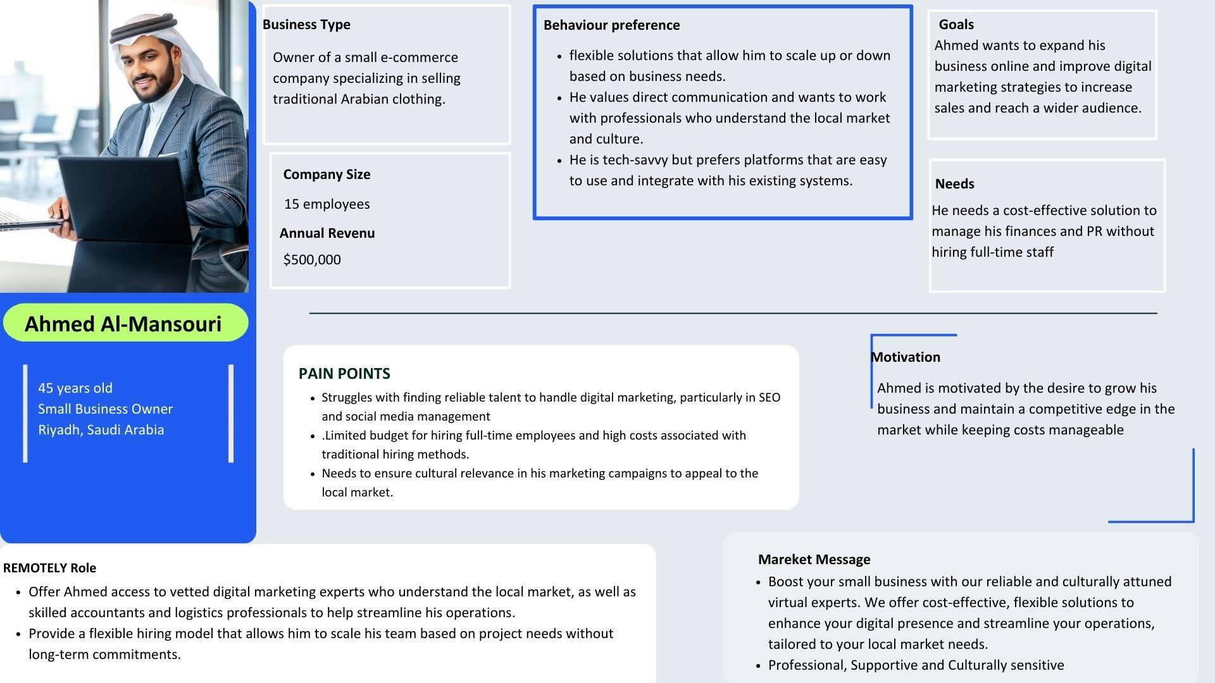

### 

## Competitors Analysis

1. **Upwork**

**Strengths:**

* **Global Reach**: Upwork is one of the largest freelance platforms globally, offering access to a wide pool of talent.
* **Diverse Skill Sets**: Covers nearly every category of freelancing, including design, tech, marketing, HR, and administrative tasks.
* **Brand Trust:** Established reputation, offering businesses the confidence of a platform that has been around for years.

**Weaknesses:**

* **High Competition**: The sheer volume of freelancers can make it difficult for businesses to find high-quality talent without sifting through many profiles.
* **Non-localized**: Upwork's services are global, and they lack specific focus on the Arab market, which limits their cultural relevance.
* **Fees:** Upwork charges a high service fee (up to 20%) which can be a deterrent for both freelancers and clients.

**How Remotely Can Compete:**

* **Localized Focus**: By targeting Arabic-speaking markets and tailoring its offerings to cultural nuances, Remotely can stand out with region-specific services.
* **Lower Fees**: Offering more affordable pricing with minimal service fees can attract local businesses looking for cost-effective solutions.
* **Specialization:** Positioning itself as a provider for specific business needs such as translation, logistics, and PR can give Remotely a competitive edge over the generalist nature of Upwork.

**2. Freelancer.com**

**Strengths:**

* **Wide Talent Pool:** Similar to Upwork, Freelancer.com has a massive number of users offering services across multiple domains.
* **Competitive Bidding**: Clients can receive multiple offers from freelancers, allowing them to choose based on price and expertise.

**Weaknesses:**

* **Quality Concerns**: With an open bidding system, some clients face challenges finding reliable freelancers as it’s not always easy to filter quality.
* **Global, not Regional**: Like Upwork, Freelancer.com doesn’t have a specific focus on the Arab market, which may result in a mismatch of cultural understanding and language challenges.

**How Remotely Can Compete:**

* **High-Quality Curation:** Remotely can offer a curated pool of vetted experts, ensuring higher quality and reliability for businesses in the region**.**
* **Language and Cultural Relevance:** By focusing on Arabic-speaking experts and culturally relevant business practices, Remotely can address the needs of local businesses better than global platforms like Freelancer.com.

**3. Target HR**

**Strengths:**

* **HR Expertise**: Target HR is a well-established company in Egypt specializing in HR outsourcing, payroll management, and compliance with local Labor laws.
* **Full-Service HR**: They offer comprehensive HR solutions, from recruitment and payroll to benefits management and Labor law consulting.
* **Large Client Base**: With a focus on large corporations and multinational companies, Target HR has built trust and credibility in the market.

**Weaknesses:**

* **Narrow Focus**: Target HR’s primary focus is HR-related services like payroll and compliance, limiting their offerings to administrative tasks.
* **High Costs**: Their comprehensive services may not be affordable or accessible to smaller businesses or startups.

**How Remotely Can Compete**:

* **Service Diversification**: Remotely can beat Target HR by offering a wider range of business functions, including virtual assistance in non-HR domains like marketing, logistics, and project management.
* **Focus on SMEs**: By targeting small and medium-sized businesses that may not need full HR outsourcing but need flexible virtual assistance, Remotely can cater to a broader audience.
* **Lower-Cost Solutions**: Offering affordable virtual assistant services will attract businesses that cannot afford Target HR’s high-level HR services.

4**.Freelance Yard**

**Strengths**

* **diverse skill set**: Almost all categories of freelancing are covered including design, technology, marketing, HR, and administrative tasks.
* **Niche Audience**: By being smaller and region-specific, Freelance Yard appeals to clients who want a localized service without the clutter of global platforms

**Weaknesses**

* **website issues:**

The Egyptian freelance platform has a significant issue as the site does not support the Arabic language.

* Problems arise with the website, whether during initial registration or with the website's links.
* The content and pages are inactive, and all channels fail to provide content consistently.
* Additionally, there are no clear and established criteria for electronic contracts, nor are there secure methods for accessing services and making payments.

**Platforms: They are active on Facebook. https://www.facebook.com/freelanceyard**

* **Content**: They share images, videos, and podcasts.
* **Frequency:** They post three times a week.
* **Engagemen**t: Their followers do not interact much with their content (likes, comments, shares).

**Their brand voice includes:**

* **Tone:** The emotional attitude expressed is friendly and humorous.
* **Style**: They communicate in an informal and converse

**Conclusion: How Remotely Can Win**

* **Localization**: Emphasizing a deep understanding of Arabic-speaking markets can give Remotely a distinct advantage over global platforms.
* **Service Diversity:** Offering a broader range of services, from HR to digital marketing, positions Remotely as a one-stop-shop for businesses, particularly SMEs and startups.
* **Affordability and Flexibility**: By providing flexible, project-based support at competitive pricing, Remotely can attract businesses that need temporary expertise without the overhead costs associated with hiring full-time staff.
* **Targeting SMEs and Startups**: Focusing on businesses that are often underserved by larger platforms or expensive HR outsourcing firms will help Remotely carve out a niche in the market.

Marketing Strategy and Plan

## Objective:

### Business Objective:

Achieve market presence in three key Arabic-speaking countries (Saudi Arabia, UAE, and Egypt) by the end of the first year, acquiring a total of 200 client businesses.

### Marketing Objective:

Build brand awareness among 50% of the target business audience in the three key markets within the first 6 months, as measured by brand recall surveys and social media reach.

### Digital Marketing Objective:

Generate 10,000 qualified leads through digital marketing channels (SEO, social media, and email marketing) in the first year, with a conversion rate of at least 5% leading to 500 new clients.

## Unique Value Proposition

Our company offers a unique value proposition by combining quality, flexibility, and specialization. We provide access to a curated pool of vetted experts with extensive experience in their respective fields. Businesses can hire these experts on a flexible basis, allowing them to scale up or down according to their project needs. Additionally, our services are tailored specifically for the Arabic-speaking market, providing a significant competitive advantage over existing platforms that primarily serve global audiences.

**With our services, businesses can:**

* **Quickly access specialized talent** without the lengthy and costly recruitment process, allowing them to respond to market demands and project needs promptly.
* **Reduce overhead costs** associated with full-time hires, while still leveraging the expertise needed to drive growth and innovation.
* **Enhance operational efficiency** by tapping into a curated pool of experts who are ready to
* deliver high-quality work, tailored to the specific cultural and business contexts of the Arabic-speaking markets.
* **Adapt to changing business needs** with the flexibility to scale the workforce up or down based on project demands, without long-term commitments.
* **Ensure high-quality service** through our rigorous vetting and quality assurance processes, giving businesses peace of mind and confidence in the expertise they are hiring.

## Unique Selling Point

At Remotely, we **simplify** the talent acquisition process for our clients by eliminating the need for multiple freelance platforms. With a dedicated account manager assigned to each client, we offer a personalized experience where you have access to qualified, pre-vetted professionals whenever needed. **We are your single destination for finding top talent**, saving you from the hassle and risk of hiring unqualified individuals on freelance platforms. Our team ensures you always have the right expertise at your fingertips, giving you confidence and peace of mind with every hire. We are committed to helping businesses thrive by providing them with the right experts, right when they need them, supporting them in achieving their goals efficiently and effectively

## Tone of Voice

* **“Tone**: Professional, supportive, and resourceful. The voice should reflect expertise, flexibility, and commitment to client success.
* **Personality**: Efficient, dependable, and solution-oriented, with a focus on delivering high-quality services tailored to the client’s specific needs.
* **Language:** Clear, concise, and direct. Use authoritative language to build trust while remaining approachable. Highlight the flexibility and expertise of the virtual assistants.

**Sample Brand Voice Statements**

* "Remotely: Your virtual assistant, always available."
* "Scale your business without the overhead."
* "Find the perfect remote talent for your team."
* “The right expert when you need them, for as long as you need them.”
* “Skilled virtual professionals to elevate your business.”
* “Get top-tier services without the overhead of full-time hires.”
* “From short-term projects to ongoing support, we’ve got you covered.”

## Messaging and Storytelling

**Key Messages:**

**• Why Choose Virtual Assistance?**

Highlight the benefits of using virtual assistance, including cost savings, flexibility, and access to a wide pool of specialized talent without the overhead costs of full-time employees. Explain how virtual experts help businesses scale efficiently and focus on their core functions.

**• Why Remotely?**

* **For Businesses**: Simplified talent acquisition, no need for searching multiple platforms—Remotely assigns a dedicated account manager for all your hiring needs.
* **For Clients**: Reliable, pre-vetted professionals ensure high-quality service without the hassle of managing freelancers.
* **Emphasize Remotely deep understanding of the Arab market** and its unique focus on providing virtual assistance tailored to the region's specific business needs. Showcase the dedicated account manager who handles all talent sourcing, eliminating the need for clients to search multiple platforms.
* **Client Success Stories:** Share testimonials and case studies that demonstrate how Remotely has helped businesses grow by providing expert support in areas such as HR, marketing, and logistics. Use these stories to build credibility and trust, showing how Remotely drives real results.
* **Flexibility and Growth:** Explain how Remotely offers scalable solutions that align with the changing needs of businesses. Whether clients need temporary project help or ongoing support, Remotely provides flexible packages designed to enhance productivity without long-term commitments

## 

## Digital Marketing Channels

Given Remotely focus on connecting businesses and freelancers, we will consider these platforms

### **LinkedIn**:

### A professional networking platform ideal for reaching businesses. Focus on professional connections, case studies, and industry insights to target businesses in need of virtual assistance. Highlight client testimonials, success stories, and partnerships.

* **Context**: LinkedIn will allow Remotely to establish thought leadership by sharing case studies, market insights, market analysis, company updates**,** and join business related communities.
* **Tone:** Formal, professional, data-driven.

### Instagram:

Visual storytelling about the different industries served, showcasing behind-the-scenes looks at virtual assistants in action and business achievements. Use stories for quick tips and highlights.

* **Context:** Remotely can showcase visuals of different services we deliver, success stories and business insights. It can also provide highlights of events or conferences that the company participates in.
* **Tone:** Visual storytelling, inspirational, and engaging.

### Facebook:

Utilize ads targeting SMEs, Startups and targeted persona looking to hire virtual experts. Facebook is a widely used platform that can help Remotely engage with small business communities and promote Remotely services, targeting a broader audience, including small and medium enterprises and different companies**.**

* **Context**–Educational posts, tips for businesses, promotional offers, share updates, blog posts, and articles
* **Tone**: Casual yet informative.

### X (Twitter):

Is an excellent platform for sharing real-time updates, industry news, new regulations, government incentives, and engaging in conversations related to the talents and virtual expert’s market.

* **Context:** Quick updates, industry news, and engaging with relevant business trends and conversations. This is also a good platform for customer service and responding to queries.
* **Tone**: Concise, authoritative, and informative.

### **Website**:

Optimize the website for lead generation with contact forms, success stories, and a blog focusing on business needs and employments.

The website should be SEO friendly to improve visibility, attract more organic traffic and enhance its ranking on (SERPs)

### YouTube:

Video content is highly engaging, and YouTube is an ideal platform for sharing detailed explanations of services, client’s testimonials, and case studies.

* **Context**: Remotely can produce educational videos that showcase how Remotely services work, case studies, and client testimonials. Tutorial content on how businesses can benefit from outsourcing specific tasks.
* **Tone:** Informative, detailed, and educational**.**

## Remotely Marketing plan

To effectively market Remotely services, it's essential to use tactics that align with the company’s goals and message. Here are the best marketing tactics to consider:

### Content Marketing:

* **Blog Posts and Case Studies**: Regularly publish SEO-optimized blog posts and detailed case studies showcasing how Remotely has successfully helped clients with virtual assistance. Focus on topics like business efficiency, remote work solutions, and cost-effective hiring strategies.
* **Video Testimonials**: Create video content featuring satisfied clients discussing their experiences with Remotely. Use this across social media, email campaigns, and on the website to build trust and credibility.

### SEO & Website Optimization

* **Local SEO**: Optimize for local search in the Arabic-speaking countries you target by using localized content and Google My Business listings to attract regional clients.
* **Keyword Targeting**: Focus on key phrases relevant to virtual assistance, such as “virtual experts in Saudi Arabia” or “remote business support UAE.” Ensure these are embedded in website copy, blogs, and landing pages.
  + - remote careers
    - work from home agencies
    - remote closing job
    - at home jobs hiring
    - remote project manager jobs
    - work from home companies’ jobs
    - work from home companies 2024
    - remote work from home agencies
    - work from home job for companies
    - list of work from home companies

### Paid Advertising

* **Facebook Ads**: Run targeted Facebook ad campaigns focusing on small business owners and startups in the Arab world. Promote special offers and free consultations to attract leads.



Target Audience

1. Geography:

● Saudi Arabia

● United Arab Emirates

● Egypt

2. Demographics:

● Age: 25-55 - Gender: All

● Job Titles: Business Owners, HR Managers, Project Managers, Marketing

Directors, Financial Controllers, SME Owners

● Business Size: Small to Medium Enterprises (SMEs)

3. Interests:

● Remote Work

● Freelancing

● Digital Marketing

● Entrepreneurship

● HR Management

● Business Development

● Technology

Ad Campaign Structure

Ad Formats:

● Carousel Ads showcasing different service offerings

● Video Ads featuring testimonials or explainer videos

● Image Ads highlighting pain points and solutions

Ad Copy Examples:

1. Pain Point: Limited Access to Specialized Talent

● Headline: "Struggling to Find Specialized Talent?"

● Body: "Hire top-notch virtual experts across accounting, marketing, and

more—on your terms. Flexible, cost-effective solutions are just a click away.

Discover REMOTELY today!"

● Call to Action (CTA): "Get Started Now"

2. Pain Point: High Hiring Costs

● Headline: "Cut Hiring Costs by 50%!"

● Body: "Why pay for full-time employees when you can hire specialized talent

for short-term projects? Explore our cost-effective virtual expert services

tailored for your business."

● CTA: "Learn More"

3. Pain Point: Inflexibility of Workforce

● Headline: "Scale Your Workforce with Ease!"

● Body: "Need to adapt quickly to project demands? Our virtual experts provide

the flexibility you need without the overhead costs. Start hiring remotely

today!"

● CTA: "Discover More"

4. Pain Point: Time Constraints

● Headline: "Fast-Track Your Projects!"

● Body: "Tight deadlines? Our pool of virtual experts is ready to tackle urgent

tasks. Don’t let time constraints hold you back—partner with REMOTELY!"

● CTA: "Find Your Expert"

5. Pain Point: Quality Control and Trust Issues

● Headline: "Quality You Can Trust!"

● Body: "At REMOTELY, we vet our experts to ensure high-quality service.

Gain peace of mind and hire with confidence!"

● CTA: "Join Us Today"

Budget Allocation

● Daily Budget: $10 (Total for 30 days = $300).

● Ad Testing: Use A/B testing for different ad copies and formats to determine what

resonates best with your audience. Aim to run multiple variations of each ad to

maximize engagement.

Metrics to Track

● Reach and Impressions: Measure how many people see your ads.

● Engagement Rate: Track likes, shares, and comments to gauge interest.

● Click-Through Rate (CTR): Monitor how many users click on the CTA.

● Conversion Rate: Track the number

* **Google Ads:** Use Google Ads to target keywords related to virtual assistance, freelance support, and remote work. Focus on capturing leads searching for project-based or temporary support services in key regions.



Campaign Objectives:

● Increase Brand Awareness: Position REMOTELY as a go-to platform for virtual

expert hiring.

● Generate Leads: Drive traffic to the website and capture potential client information.

● Promote Services: Highlight specialized services offered by REMOTELY.

Target Audience:

1. Geography:

○ Saudi Arabia

○ United Arab Emirates (UAE)

○ Egypt

2. Demographics:

○ Age: 25-55

○ Gender: All

○ Job Titles: Business Owners, HR Managers, Project Managers, Marketing

Directors, Accountants, Small to Medium Enterprise (SME) Owners

○ Company Size: Small and Medium Enterprises (SMEs)

3. Interests:

○ Remote Work, Freelancing, Digital Marketing, Business Efficiency, Workforce Flexibility, and Technology Solutions

Pain Points to Address in Ads:

1. Limited Access to Specialized Talent: Highlight the platform’s ability to connect

businesses with skilled professionals in various fields.

2. High Hiring Costs: Emphasize cost-effectiveness compared to traditional hiring

methods.

3. Inflexibility of Workforce: Promote flexibility in hiring virtual experts for short-term

projects.

4. Time Constraints and Urgent Needs: Showcase quick access to experts for urgent

project demands.

5. Quality Control and Trust Issues: Ensure potential clients know about the vetting

process and quality assurance.

Ad Structure:

Campaign Types:

● Search Ads: Target specific keywords related to hiring virtual experts.

● Display Ads: Use visually appealing banners to increase brand visibility.

Example Ad Groups and Keywords:

1. Ad Group: Hire Virtual Experts

○ Keywords: "hire virtual experts", "freelance professionals in [specific field]",

"remote workers for short-term projects"

○ Ad Copy:

■ Title: "Find Top Virtual Experts Today!"

■ Description: "Access specialized talent in accounting, marketing, and

more. Cost-effective and flexible solutions for your business. Start

hiring now!"

2. Ad Group: Cost-Effective Hiring

○ Keywords: "affordable hiring solutions", "reduce hiring costs", "flexible

staffing"

○ Ad Copy:

■ Title: "Cut Hiring Costs by 50%!"

■ Description: "Tired of high recruitment expenses? Discover

REMOTELY—affordable access to expert talent without the overhead.

Get started today!"

3. Ad Group: Fast and Reliable Service

○ Keywords: "urgent project help", "fast virtual hiring", "quick access to experts"

○ Ad Copy:

■ Title: "Need Help Now? Hire Virtual Experts!"

■ Description: "Meet tight deadlines with our vetted virtual

professionals. Get quality work, fast! Explore our services today."

Budget Allocation:

● Total Budget: $500

● Daily Budget: Approximately $16.67

Performance Metrics:

1. Click-Through Rate (CTR): Measure engagement with ads.
2. Cost Per Click (CPC): Monitor spending efficiency.
3. Conversion Rate: Track the number of leads generated from clicks.
4. Impressions: Evaluate reach and brand visibility.

### Email Marketing

* **Lead Nurturing Campaigns**: Set up automated email workflows that nurture leads from initial interest to conversion. Provide value through industry insights, service highlights, and case studies. Offer special promotions or free trials in later stages to encourage conversion.
* **Drip Campaigns**: Use drip campaigns for re-engaging potential clients who have shown interest but haven’t converted. Highlight Remotely flexibility, cost savings, and personalized services.

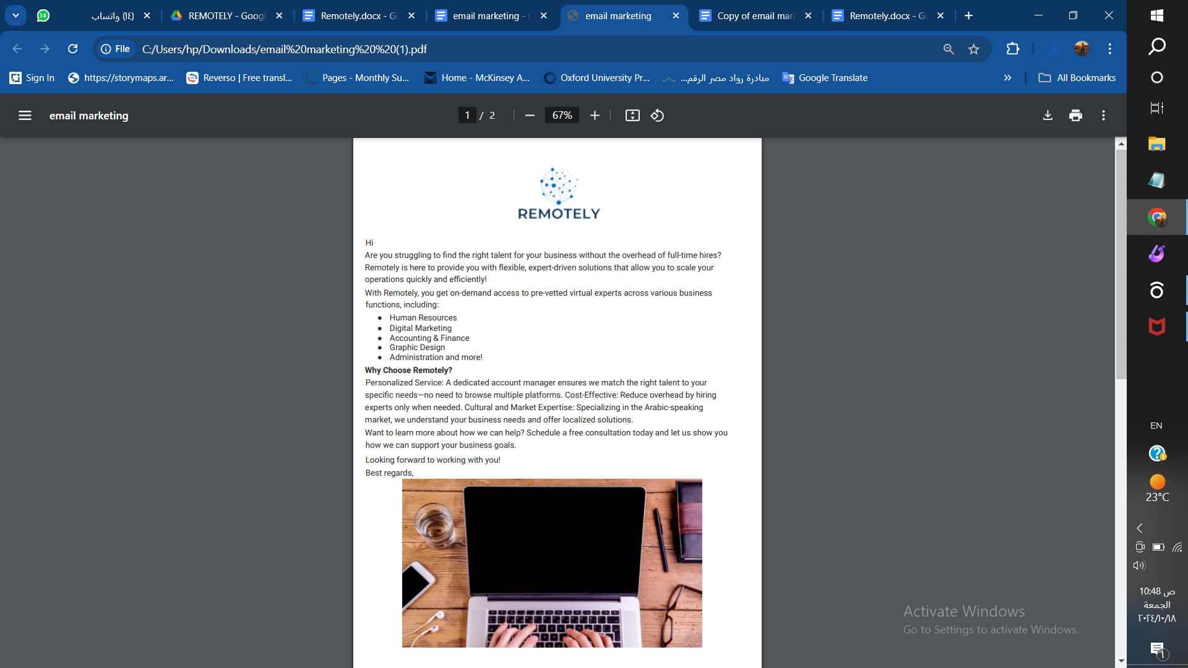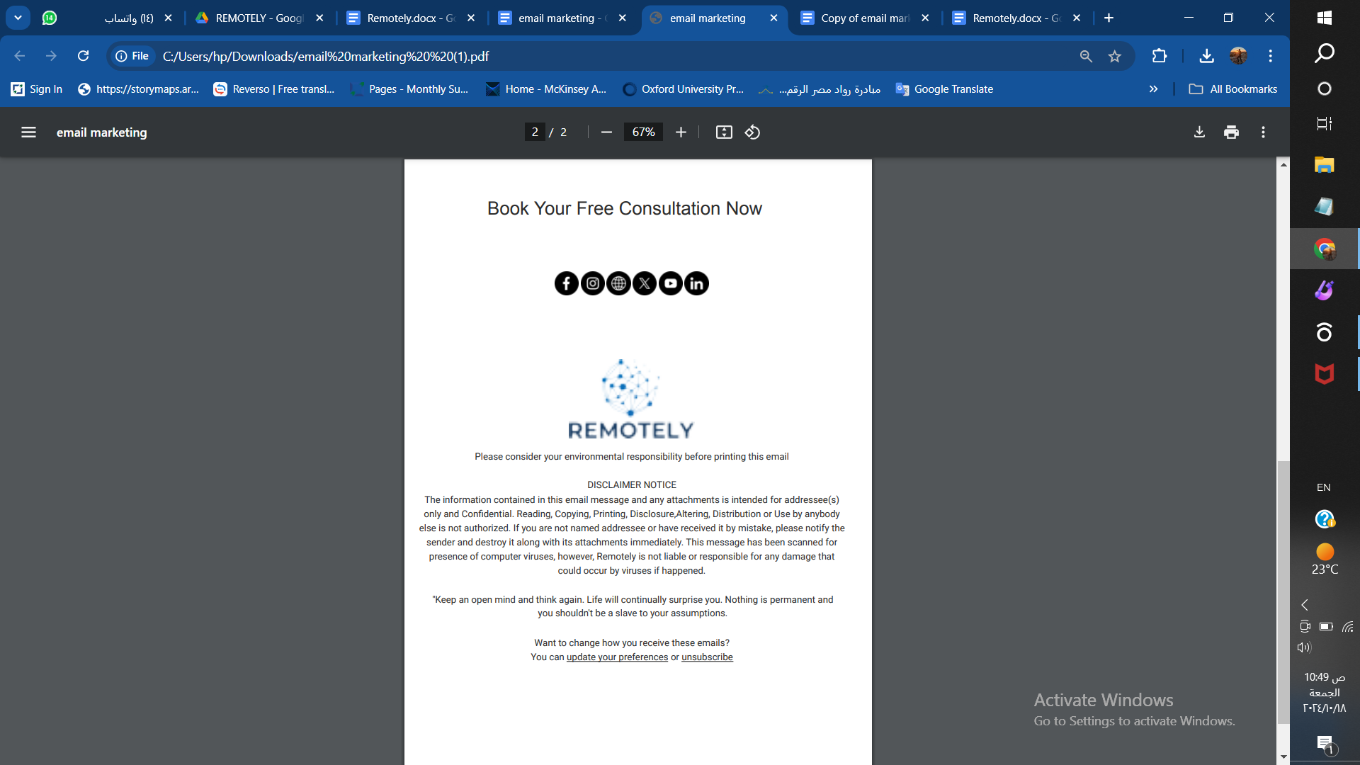

### Influencer and Partnership Marketing

* **Business Network Partnerships**: Form partnerships with local business associations and chambers of commerce to promote Remotely as a preferred virtual assistant provider. Participate in webinars and events to showcase your expertise.
* **Influencer Collaborations**: Partner with micro-influencers and business coaches in Saudi Arabia, UAE, and Egypt to promote Remotely’s services through their networks. Offer them free access or a sponsorship deal in exchange for testimonials and promotional posts.

1. **Mohamed El Shafey**

**Specialization :** He is a popular Egyptian figure on Instagram, specializing in personal development, business coaching, and motivational speaking. His content focuses on entrepreneurship, mindset growth, and business success, and he engages actively with a large, young audience interested in business tips, economic trends, and personal growth.

**Why Collaborate?**

1. Audience: His followers consist of aspiring entrepreneurs, business professionals, and young people interested in economic empowerment, personal growth, and business development.
2. Influence: With his consistent messaging on entrepreneurship and business strategy, Mohamed El Shafey is well-positioned to promote Remotely’s services, especially for entrepreneurs and startups looking to optimize their businesses through virtual assistants.
3. Fit for Affiliate Marketing: He could be a good fit for affiliate marketing as his platform is ideal for promoting cost-effective business solutions like Remotely’s, and he can directly engage with followers through special offers or referral codes.
4. **Platform:** Instagram

**2.Hala Kazim (UAE)**

* + **Specialization**: Life coaching, motivational speaking, and personal development.
  + **Why Collaborate?** Hala is known for her empowering talks to business owners and entrepreneurs, focusing on achieving balance and success. Her influence among female entrepreneurs and business owners in the UAE and broader Arab region makes her an ideal partner to promote Remotely's virtual assistance services.
  + **Platform**: Instagram, LinkedIn, and YouTube.

**3.Omar Samra (Egypt)**

* + **Specialization:** Adventurer, entrepreneur, and motivational speaker.
  + **Why Collaborate?** As an entrepreneur and founder of various ventures, Omar appeals to business owners and startups seeking innovation and growth. His inspirational approach can attract Remotely’s target audience in the tech and entrepreneurial sectors.
  + **Platform:** Instagram, LinkedIn, and Twitter.

### Referral Program

* **Client Referral Incentives**: Offer existing clients discounts or service credits when they refer new businesses. Promote this through email campaigns and social media.
* **Affiliate Program**: Set up an affiliate program where local business consultants or industry influencers can earn commissions by referring new clients to Remotely.

### Webinars and Events

* **Online Webinars**: Host educational webinars on topics such as how to manage a virtual workforce, strategies for scaling businesses through remote talent, and cost-effective solutions for business growth. Use these events to build authority and generate leads.
* **Local Business Events**: Sponsor or participate in regional business conferences and expos to network with potential clients and showcase Remotely services.
* **Sponsor and participate in employments fairs**

### Mobile Marketing Strategy

**Target Audience**

* Small businesses and startups seeking flexible virtual assistance.
* Entrepreneurs needing affordable, short-term expert support.
* Mid-sized enterprises looking for remote HR, marketing, or admin help.

**Optimize for App Store (ASO)**

To ranks highly in app stores by:

* Choosing relevant keywords based on what your audience might search for.
* Creating compelling titles and descriptions highlighting Remotely unique services (e.g., "Virtual Assistant for Small Businesses").
* Using high-quality visuals such as app screenshots and videos to showcase how the app works.
* Encouraging positive reviews from early users to boost credibility and visibility.

**Leverage Social Media Marketing**

* Promote our app across social media platforms to drive awareness and downloads:
* Instagram: Use stories, reels, and influencer partnerships to demonstrate real-world use cases.
* LinkedIn: Share success stories and case studies that appeal to businesses needing virtual assistance.
* Facebook: Run ads targeting small business owners and startups in the Arab world, emphasizing convenience and cost-effectiveness.
* Action: Create video tutorials, behind-the-scenes clips, and customer testimonials to build credibility and attract potential users.

**In-App Referral Program**

Encourage users to refer your app to others by:

* Offering referral bonuses or discounts for both the referrer and the new user.
* Implementing easy sharing options within the app, allowing users to share links to their network via social media or email.

**Influencer Partnerships**

* Collaborate with influencers in the business, entrepreneurial, and tech spaces to promote your app:
* Reach out to micro-influencers with strong ties to small business communities.
* Offer them free access to the app or paid promotions in exchange for a review or demonstration of the app’s value.
* Push Notifications & Retargeting
* Increase user retention through personalized and timely push notifications:
* Notify users of service availability, discount offers, or new features.
* Use retargeting ads to reach users who downloaded the app but haven’t used it recently or haven’t signed up for services.

**App Analytics & Continuous Optimization**

* Leverage analytics tools to track user behaviour and improve the app:
* Monitor key metrics such as download rates, user retention, and in-app engagement.
* Use this data to optimize your app’s user experience, removing any barriers to service usage.
* Action: Continuously gather feedback from users to make updates and improvements that align with their needs.

**Paid Ads & App Install Campaigns**

* Use Google Ads, Facebook Ads, and other mobile ad platforms to promote app downloads:
* Target ads toward specific demographics like entrepreneurs or small business owners in the Arab world.
* Use App Install Ads to drive direct downloads from social media or search engines.

**Content Marketing**

* Create high-value, educational content about the benefits of using Remotely’s services:
* Post blog articles or video content highlighting how businesses can save time and money with virtual assistance.
* Use this content to engage users and funnel them towards downloading the app.

**Email Marketing**

Build and nurture an email list of potential users:

* Offer an email drip campaign to introduce the app’s features and explain the value of virtual assistance.
* Follow up with users who downloaded the app but haven’t engaged with it yet, providing them with tips or incentives to try the services.

**Timeline**

* Pre-launch: Build anticipation through social media, email sign-ups, and influencer collaborations.
* Launch: Focus on ASO, paid app installs ads, and social media campaigns.
* Post-launch: Retain users through push notifications, referral programs, and continuous app improvements.

**KPIs to Track**

* Download and installation rates
* Daily/weekly active users (DAU/WAU)
* Conversion rates (from download to active user)
* Retention rates (how long users stay engaged)
* App store ratings and reviews

### **Community Building:**

A community-based approach will allow Remotely to not only promote its services but also position itself as a thought leader in the Virtual Expert provider in the targeted countries. It creates a space for valuable engagement, trust-building, and collaboration, which will, in turn, enhance customer acquisition and brand loyalty.

* **LinkedIn Groups**: Establish and join professional communities on LinkedIn, which can serve as a platform for sharing business insights, engaging with industry professionals, and networking with potential investors.
* **Facebook Groups**: Build a more personal, interactive community space where entrepreneurs, and experts can have informal discussions and share experiences.

### Search Engine Optimization (SEO)

Ranking high on Google for key words related to virtual experts is crucial to attract international clients searching for virtual experts**.**

**Keyword Optimization:** Target phrases like Target phrases like “Virtual Assistants in Saudi Arabia,” “Freelance experts in UAE,” and “Hire remote professionals Egypt.”

* **Backlinks:**
* **On-Page SEO**.
* **SEO Keywords Research**

### Content Calendar

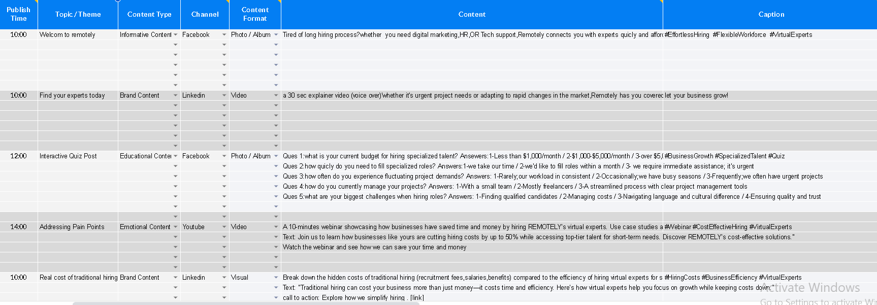

### Budget

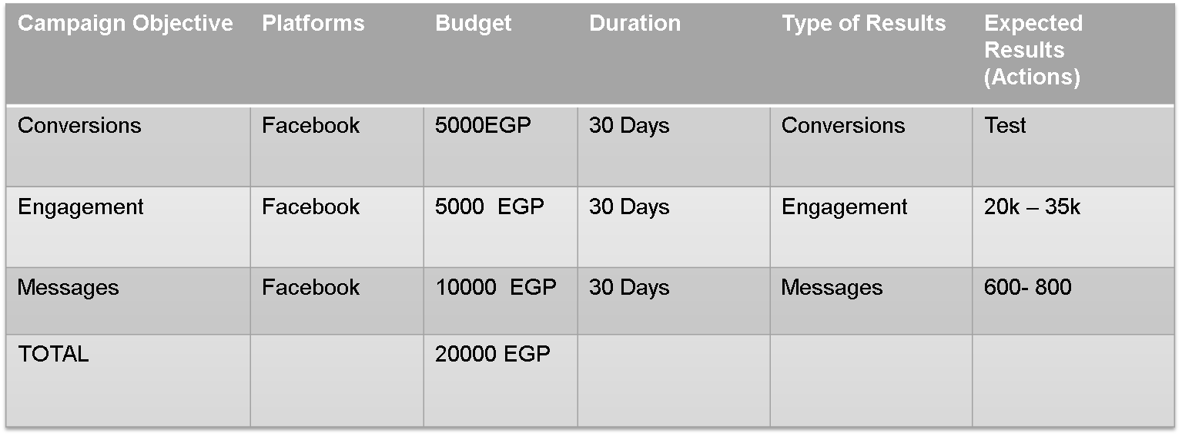

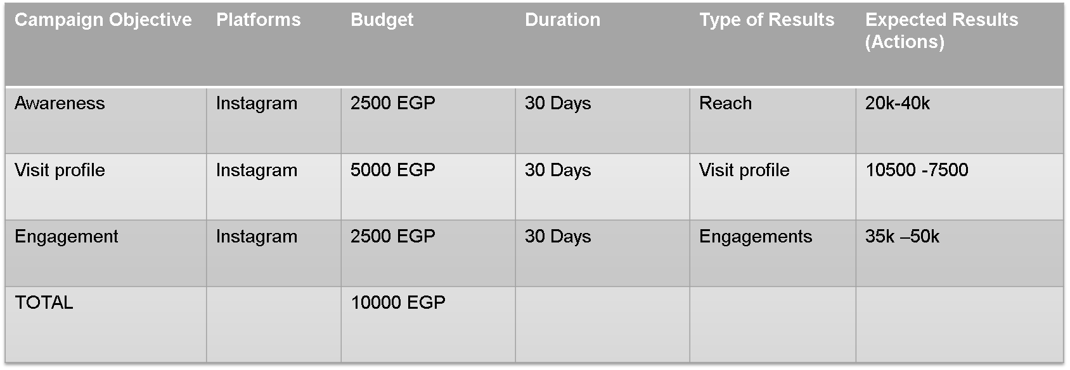

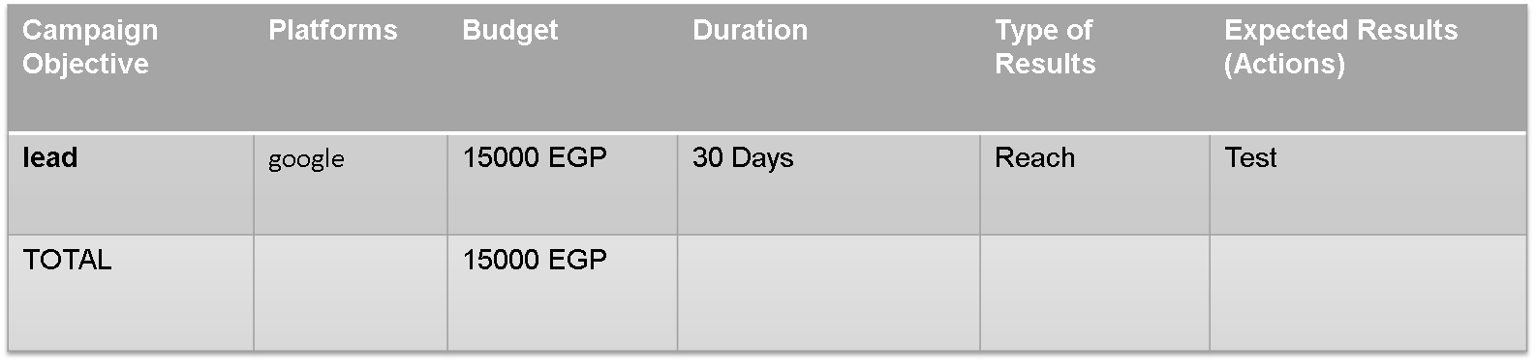

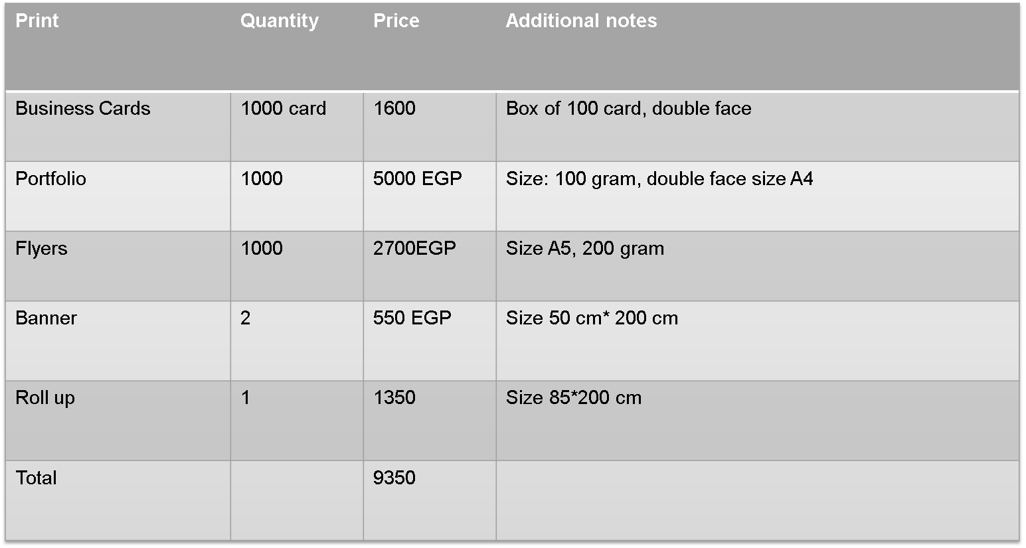

### Performance Tracking and KPIs

* **Website:**

1. **Traffic:**

* Unique Visitors
* Bouncing rate
* Page views
* Organic reach

1. **Engagement:**
   * **Page per session**
2. **Conversion:**
   * Conversion number
   * Conversion rate
3. **SEO:**
   * Keywords Ranking
   * Organic search volume

* **Social Media:**
  + 1. **Engagement**: Monitor engagement rates across social media platforms (likes, shares, comments)
    2. **Reach:** (Impression, subscribe)
    3. **Conversion**: (no of Clicks to website, no of Leads)
* **Email Marketing:**

1. Open rate
2. Bounce rate
3. Click Through Rate (CTR)
4. Conversion rate

* **Client Acquisition**: Track the number of new clients acquired each quarter and their corresponding project values.
* **ROI:** Return Of Investment